Overview

Profile Synchronization is the manner in which profile header and profile allocation is replicated to external systems, like MDUS. This is needed to link profile data in SAP and an MDUS system, so the profile data can be loaded and billed in SAP.

Profile Synchronization happens automatically during certain processes, including meter installation/replacement. However, there are cases where the synchronization encounters an error, for example the MDUS system was not available at time of synchronization or there are system error encountered. In these cases, Profile Synchronization needs to be triggered manually.

A mass activity is available in SAP for synchronizing profiles on demand.

Business Process Procedure Overview
Overview of Process to be followed
- Display Profile Synchronization initial screen
- Provide selection parameters and save the run id
- Schedule the program run
- Monitoring

Procedural Steps

Display Profile Synchronization initial screen

(Transaction Code can be displayed by selecting System -> Status)
EAMIPROFSYNC

Execute transaction EAMIPROFSYNC to get to the Profile Synchronization for AMI initial screen.

The following screen will be displayed.

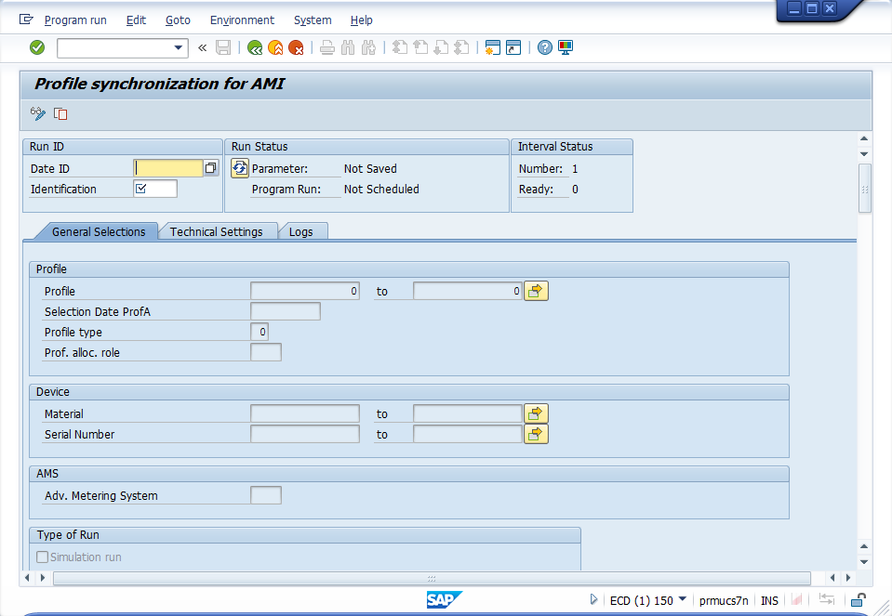

Provide selection parameters and save

Enter the following information and click on the save icon.
- Date ID: Today’s date
- Identification: User’s initial + sequential number
- Profile: Profile number to be synched
- Adv. Metering System: AMS of the device where the profile is allocated

Note: Details on how to get the Profile and AMS will be explained in the next few pages.

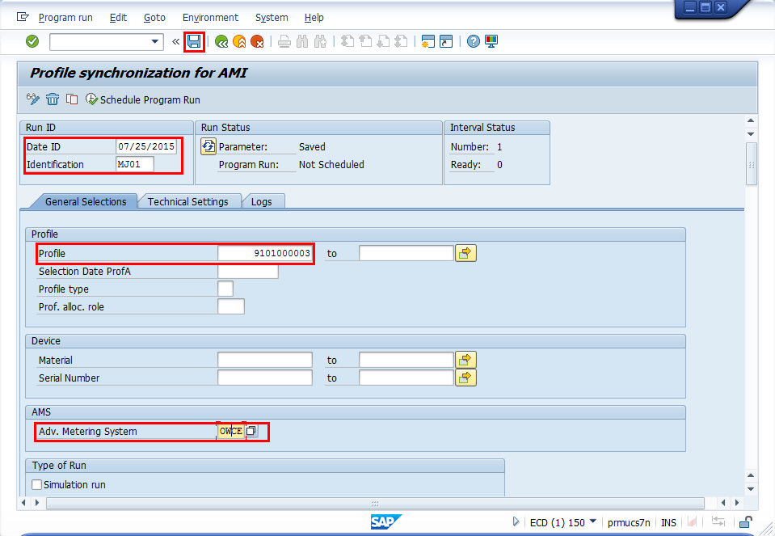

Click on Save.

Execute the job

Click on the Schedule Program Run.

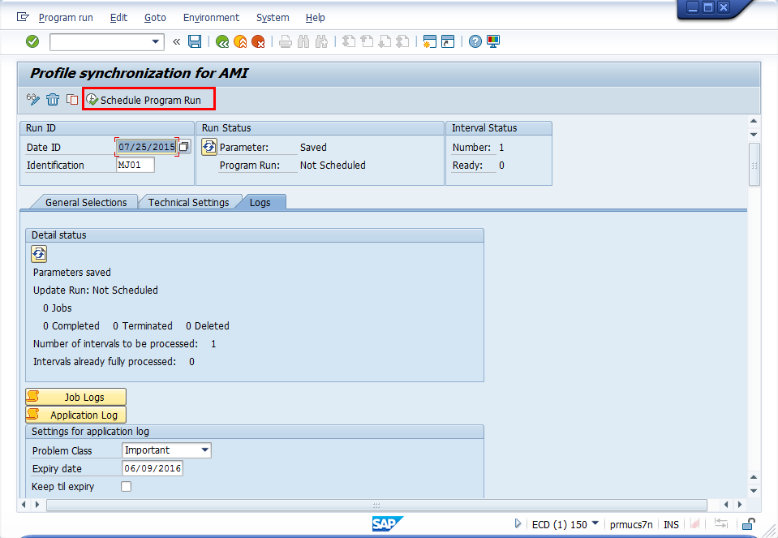

Select Background – Start Immediate, then click on OK.
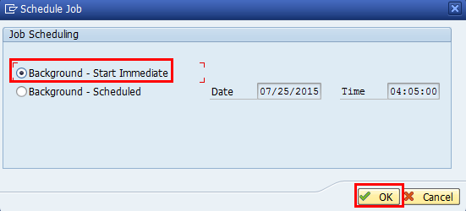

This will trigger the Profile Synchronozation.

Monitoring

(Transaction Code can be displayed by selecting System -> Status)
EAMIMONI01

Execute transaction EAMIMONI01 to get to the Monitoring of AMI Communication initial screen.

Choose Object Type Profile and enter the profile number you have synchronized.

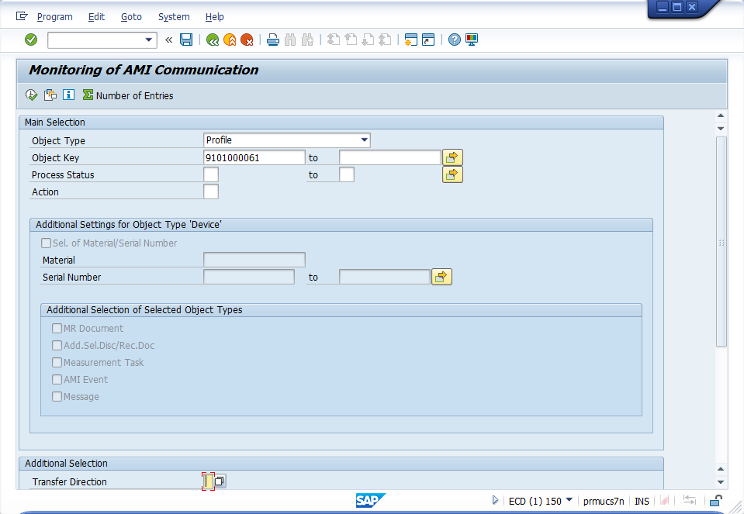

Click on Execute

The AMI Monitoring screen will be displayed.

Successful profile synchronization will have a Proc. Status of Action Completed Successfully.
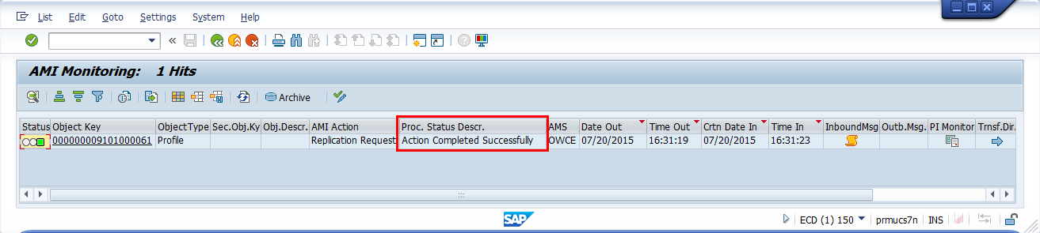

Details on how to find the Profile and AMS

To get the profile, execute transaction EEDM08 to get to the Profile Header screen. Enter the installation number.

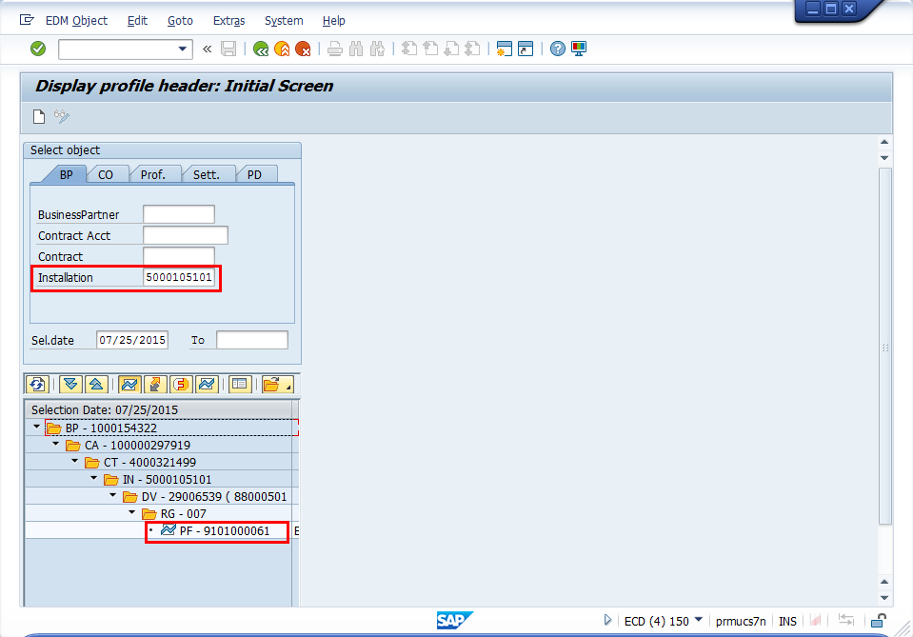

To get the Advance Metering System, go to the device details. The AMS field can be seen in the AMI tab.

